Table of Contents
Chapter One 3
Setting up Your Excel Microsoft Excel 2007 Environment 3
Exploring and Setting Up Your Excel Environment 3
Starting a Workbook 7
Your First Workbook 7
Chapter Two 10
Working with cells and worksheets 10
Columns, Rows, and Cells 11
Worksheets 14
Naming Worksheets 14
Inserting Worksheets 15
Deleting Worksheets 16
Grouping and Ungrouping Worksheets 16
Freezing Worksheet Panes 17
Chapter Three 19
Formatting 19
Formatting Tables 24
Aligning Text 26
Changing Vertical Cell Alignment 27
Changing Text Control 28
Chapter 4 29
Formulas and Functions 29
Creating More Formulas 32
Working with Cells 35
Using Cell References 38
What is an Absolute Reference? 39
Functions 41
Excel's Different Functions 42
Accessing Excel 2007 Functions 46
Chapter 5 47
Sorting, Grouping, and Filtering Cells 47
Sorting, Grouping, and Filtering 47
Sorting 47
Grouping Cells Using the Subtotal Command 50
Filtering Cells 52
Chapter 6 54
Using What-if Analysis 54
Example 55
What-If Analysis Tools 56
Goal Seek 57
Chapter 7 59
Working with Charts 59
Creating a Chart 59
Identifying the Parts of a Chart 60
Chart Tools 61
Chapter 8 63
Printing Workbooks 63
Preparing to Print and Printing 64

Chapter One

Setting up Your Excel Microsoft Excel 2007 Environment
Before you begin creating spreadsheets in Excel, you may want to set up your Excel environment and become familiar with a few key tasks and features such as how to minimize and maximize the Ribbon, configure the Quick Access toolbar, switch page views, and access your Excel options.

Exploring and Setting Up Your Excel Environment
The tabbed Ribbon menu system is how you navigate through Excel and access the various Excel commands. If you have used previous versions of Excel, the Ribbon system replaces the traditional menus. Above the Ribbon in the upper-left corner is the Microsoft Office Button. From here, you can access important options such as New, Save, Save As, and Print. By default the Quick Access Toolbar is pinned next to the Microsoft Office Button, and includes commands such as Undo and Redo.
At the bottom, left area of the spreadsheet, you will find worksheet tabs. By default, three worksheet tabs appear each time you create a new workbook. On the bottom, right area of the spreadsheet you will find page view commands, the zoom tool, and the horizontal scrolling bar.
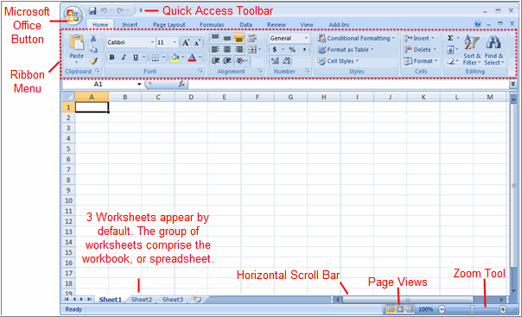

To Zoom In and Out:
- Locate the zoom bar in the bottom, right corner.
- Click the slider and drag it to the left to zoom in and to the right to zoom out.

To Scroll Horizontally in a Worksheet:
- Locate the horizontal scroll bar in the bottom, right corner.
- Click the bar and move it from left to right.

To Change Page Views
- Locate the Page View options in the bottom, right corner. The Page View options are Normal, Page Layout, and Page Break.
- Click an option to select it
The default is Normal View.

To Add Commands to the Quick Access Toolbar:
- Click the arrow to the right of the Quick Access toolbar.
- Select the command you wish to add from the drop-down list. It will appear in the Quick Access toolbar.
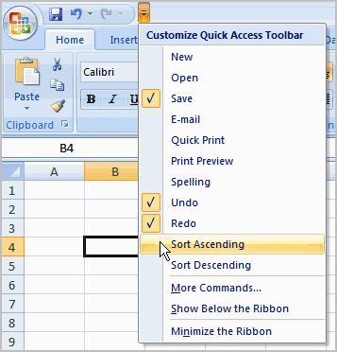
OR
- Select More Commands from the menu and a dialog box appears.
- Select the command you wish to add.
- Click the Add button.
- Click OK.
The Save, Undo, and Redo commands appear by default in the Quick Access toolbar. You may wish to add other commands to make using specific Excel features more convenient for you.

To Minimize and Maximize the Ribbon:
- Click the drop-down arrow next to the Quick Access toolbar.
- Select Minimize Ribbon from the list. The Ribbon disappears.
- To maximize the ribbon, click the arrow again and select Minimize the Ribbon to toggle the feature off.
- You can also minimize and maximize the Ribbon by right-clicking anywhere in the main menu and selecting Minimize the Ribbon in the menu that appears.
- The new, tabbed Ribbon system replaces traditional menus in Excel 2007. It is designed to be responsive to your current task and easy to use; however, you can choose to minimize the Ribbon if you would prefer to use different menus or keyboard shortcuts.

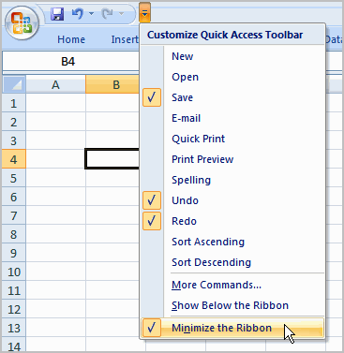

The Microsoft Office Button
The Microsoft Office Button appears at the top of the Excel window. When you click the button, a menu appears. From this menu you can create a new spreadsheet, open existing files, save files in a variety of ways, and print. You can also add security features, send, publish, and close files.
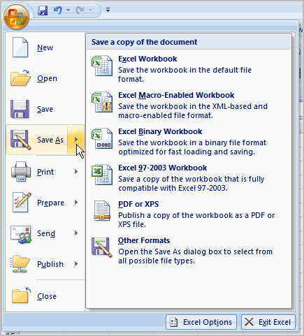

To Change the Default Excel Options:
- Click the Excel Options button. A dialog box will appear.
- Select a category on the left to access different Excel options.
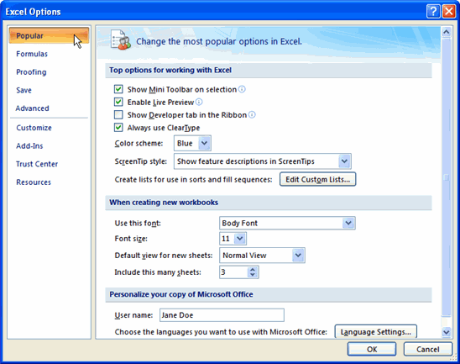
- Modify any of the default settings.
- Click OK.
As you learn more about Excel and become proficient at using it, you may want to modify some of the settings. As a beginning user, it is usually best to leave the default settings.

Starting a Workbook
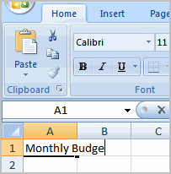
You will need to know how to insert text and numbers into Excel workbooks to be able to use it to calculate, analyze, and organize data. In this lesson, you will learn how to create a new workbook, insert and delete text, navigate a worksheet, and save an Excel workbook.

Your First Workbook

To Create a New, Blank Workbook:
- Click the Microsoft Office Button.
- Select New. The New Workbook dialog box opens and Blank Workbook is highlighted by default.
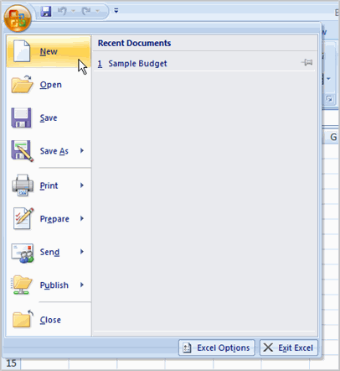

- Click Create. A new, blank workbook appears in the window.
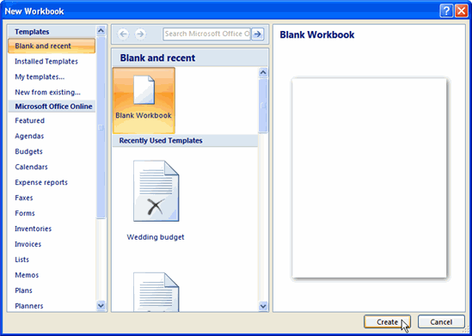

When you first open Excel, the software opens to a new, blank workbook.

To Insert Text:
- Click a cell to select it. Each rectangle in the worksheet is called a cell. As you select a cell, the cell address appears in the Name Box.
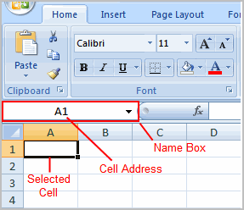

- Enter text into the cell using your keyboard. The text appears in the cell and in the formula bar.
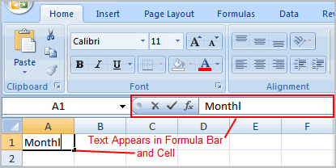

Each cell has a name, or a cell address based on the column and row it is in. For example, this cell is C3 since it is where column C and row 3 intersect.
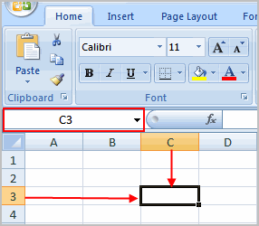

To Edit or Delete Text:
- Select the cell.
- Press the Backspace key on your keyboard to delete text and make a correction.
- Press the Delete key to delete the entire contents of a cell.
You can also make changes to and delete text from the formula bar. Just select the cell and place your insertion point in the formula bar.

To Move Through a Worksheet Using the Keyboard:
- Press the Tab key to move to the right of the selected cell.
- Press the Shift key and then the Tab key to move to the left of the selected cell.
- Use the Page Up and Page Down keys to navigate the worksheet.
- Use the arrow keys.

To Save the Workbook:
- Click the Microsoft Office Button.
- Select Save or Save As.
  - Save As allows you to name the file and choose a location to save the spreadsheet. Choose Save As if you'd like to save the file for the first time or if you'd like to save the file as a different name.
  - Select Save if the file has already been named.
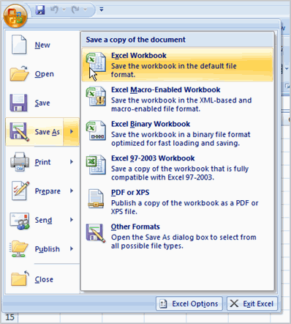
You can save a workbook in many ways, but the two most common are as an Excel Workbook, which saves it with a 2007 file extension, and as an Excel 97-2003 Workbook, which saves the file in a compatible format so people who have earlier versions of Excel can open the file.

Chapter Two

Working with cells and worksheets
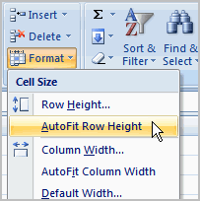

When you open a new, blank workbook, the cells, columns, and rows are set to a default size. You do have the ability to change the size of each, and to insert new columns, rows, and cells, as needed. In this lesson, you will learn various methods to modify the column width and row height, in addition to how to insert new columns, rows, and cells.

Columns, Rows, and Cells

To Modify Column Width:
- Position the cursor over the column line in the column heading and a double arrow will appear.

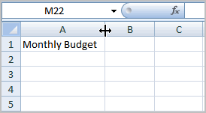

- Click the mouse and drag the cursor to the right to increase the column width or to the left to decrease the column width.
- Release the mouse button.
OR
- Click the column heading of a column you'd like to modify. The entire column will appear highlighted.
- Click the Format command in the Cells group on the Home tab. A menu will appear.
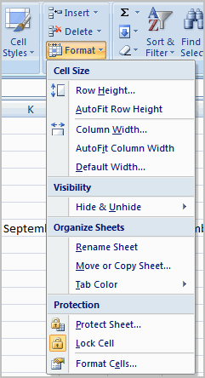

- Select Column Width to enter a specific column measurement.
- Select AutoFit Column Width to adjust the column so all the text will fit.

To Modify the Row Height:
- Position the cursor over the row line you want to modify and a double arrow will appear.

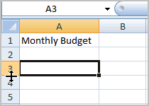

- Click the mouse and drag the cursor upward to decrease the row height or downward to increase the row height.
- Release the mouse button.
OR
- Click the Format command in the Cells group on the Home tab. A menu will appear.

- Select Row Height to enter a specific row measurement.
- Select AutoFit Row Height to adjust the row so all the text will fit.

To Insert Rows:
- Select the row below where you want the new row to appear.
- Click the Insert command in the Cells group on the Home tab. The row will appear.
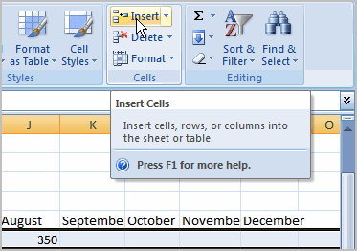

The new row always appears above the selected row.
Make sure that you select the entire row below where you want the new row to appear and not just the cell. If you select just the cell and then click Insert, only a new cell will appear.

To Insert Columns:
- Select the column to the right of where you want the column to appear.
- Click the Insert command in the Cells group on the Home tab. The column will appear.
The new column always appears to the left of the selected column. For example, if you want to insert a column between September and October, select the October column and click the Insert command.

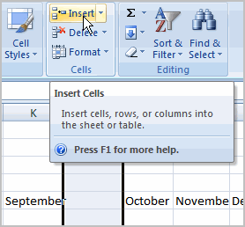

Make sure that you select the entire column to the right of where you want the new column to appear and not just the cell. If you select just the cell and then click Insert, only a new cell will appear.

To Delete Rows and Columns:
- Select the row or column you’d like to delete.
- Click the Delete command in the Cells group on the Home tab.

Worksheets

Naming Worksheets
When you open an Excel workbook, there are three sheets by default and the default name on the tabs are Sheet1, Sheet2 and Sheet3. These are not very informative names. Excel 2007 allows you to define a meaningful name for each worksheet in a workbook so you can quickly locate information.

To Name a Worksheet:
- Right-click the sheet tab to select it.
- Choose Rename from the menu that appears. The text is highlighted by a black box.
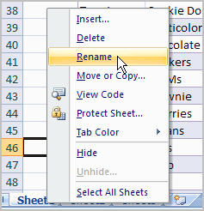

- Type a new name for the worksheet.
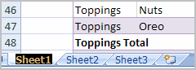

- Click off the tab. The worksheet now assumes the descriptive name defined.
OR
- Click the Format command in the Cells group on the Home tab.
- Select Rename Sheet. The text is highlighted by a black box.
- Type a new name for the worksheet.
- Click off the tab. The worksheet now assumes the descriptive name defined.

Inserting Worksheets
You can change the default number of sheets that appear by clicking the Microsoft Office Button and choosing Excel Options. You also have the ability to insert new worksheets if needed, while you are working.

To Insert a New Worksheet:
- Click the Insert Worksheet icon. A new sheet will appear. It will be named Sheet4, Sheet5 or whatever the next sequential sheet number may be in the workbook.
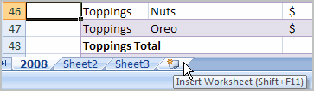
OR
- Press the Shift and the F11 keys on your keyboard.

Deleting Worksheets
Any worksheet can be deleted from a workbook, including those that have data in it. Remember, a workbook must contain at least one worksheet.

To Delete One or More Worksheets:
- Click on the sheet(s) you want to delete.
- Right-click the sheet(s) and a menu appears.
- Select Delete.
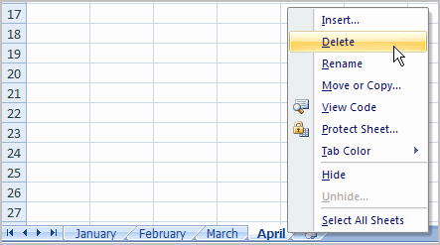
OR
- Select the sheet you want to remove.
- Click the drop-down arrow next to Delete in the Cells group on the Home tab.
- From the menu that appears, select Delete Sheet.

Grouping and Ungrouping Worksheets
A workbook is a multi-page Excel document that contains multiple worksheets. Sometimes you will want to work with the worksheets one at a time as if each is a single unit. Other times, the same information or formatting may need to be added to every worksheet.
Worksheets can be combined together into a group. Grouping worksheets allows you to apply identical formulas and/or formatting across all the worksheets in the group. When you group worksheets, any changes made to one worksheet will also be changed in any other worksheets in the group.

To Group Contiguous Worksheets:
- Select the first sheet you want to group.
- Press and hold the Shift key on your keyboard.
- Click the last sheet you want to group.
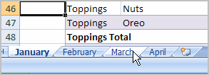
- Release the Shift key.
- The sheets are now grouped. All the sheets between the first sheet and last sheet selected are part of the group. The sheet tabs will appear white for the grouped sheets.
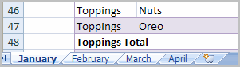
- Make any changes to one sheet and the changes will appear in all the grouped sheets.

To Group Non-Contiguous Sheets:
- Select the first sheet you want to group.
- Press and hold the Ctrl key on your keyboard.
- Click the next sheet you want to group.
- Continuing clicking the sheets you want to group.
- Release the Control key.
- The sheets are now grouped. The sheet tabs will appear white for the grouped sheets. Only the sheets selected are part of the group.
- Make any changes to one sheet and the changes will appear in all the grouped sheets.

To Ungroup Worksheets:
- Right-click one of the sheets.
- Select Ungroup from the list.

Freezing Worksheet Panes
The ability to freeze, or lock, specific rows or columns in your spreadsheet is a really useful feature in Excel. It is called freezing panes. When you freeze panes, you select rows or columns that will remain visible all the time, even as you are scrolling. This is particularly useful when working with large spreadsheets.

To Freeze a Row:
- Select the row below the one that you want frozen. For example, if you want row 1 & 2 to appear at the top even as you scroll, then select row 3.
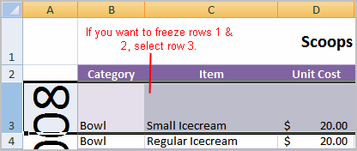

- Click the View tab.
- Click the Freeze Pane command in the Window group.
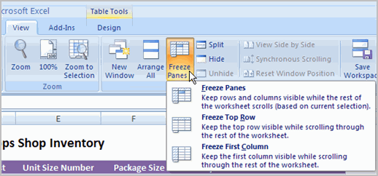

- Choose Freeze Panes. A thin, black line appears below everything that is frozen in place.
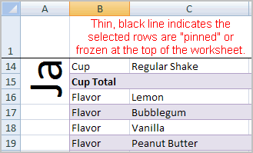

- Scroll down in the worksheet to see the pinned rows.

To Unfreeze a Pane:
- Click the Freeze Pane command.
- Select the Unfreeze command.

To Freeze a Column:
- Select the column to the right of the column(s) you want frozen. For example, if you want columns A & B to always appear on the left, just select column C.
- Click the View tab.
- Click the Freeze Pane command in the Window group.
- Choose Freeze Pane. A thin, black line appears to the right of the frozen area.
- Scroll across in the worksheet to see the pinned columns.

Chapter Three

Formatting
Once you have entered information into a spreadsheet, you will need to be able to format it

To Format Text in Bold or Italics:
- Click a cell to select it or drag your cursor over the text in the formula bar to select it.
- Click the Bold or Italics command.

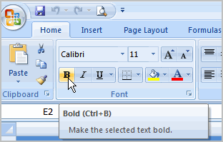

You can select entire columns and rows, or specific cells. To select the entire column, just click the column heading and the entire column will appear as selected. To select specific cells, just click a cell and drag your mouse to select the other cells. Then, release the mouse button.

To Format Text as Underlined:
- Select the cell or cells you want to format.
- Click the drop-down arrow next to the Underline command.
- Select the Single Underline or Double Underline option.
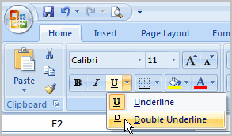

To Change the Font Style
- Select the cell or cells you want to format.
- Click the drop-down arrow next to the Font Style box on the Home tab.
- Select a font style from the list.
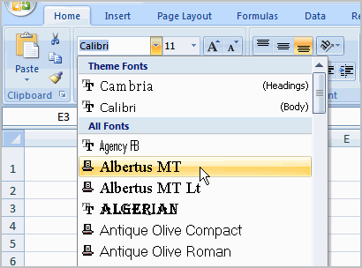

As you move over the font list, the Live Preview feature previews the font for you in the spreadsheet.

To Change the Font Size:
- Select the cell or cells you want to format.
- Click the drop-down arrow next to the Font Size box on the Home tab.
- Select a font size from the list.
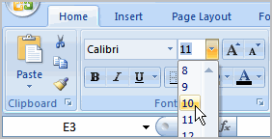

To Change the Text Color:
- Select the cell or cells you want to format.
- Click the drop-down arrow next to the Text Color command. A color palette will appear.
- Select a color from the palette.
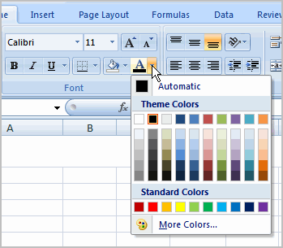
OR
- Select More Colors. A dialog box will appear.
- Select a color.
- Click OK.

To Add a Border:
- Select the cell or cells you want to format.
- Click the drop-down arrow next to the Borders command on the Home tab. A menu will appear with border options.
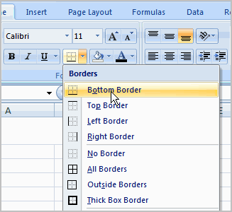
- Click an option from the list to select it.
You can change the line style and color of the border.

To add a Fill Color:
- Select the cell or cells you want to format.
- Click the Fill command. A color palette will appear.
- Select a color.
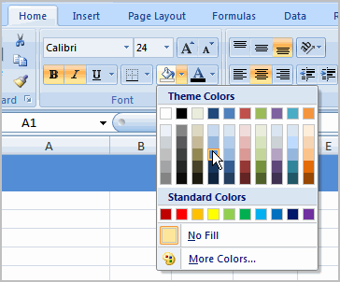
OR
- Select More Colors. A dialog box will appear.
- Select a color.
- Click OK.
You can use the fill color feature to format columns and rows, and format a worksheet so that it is easier to read.

To Format Numbers and Dates:
- Select the cell or cells you want to format.
- Click the drop-down arrow next to the Number Format box.
- Select one of the options for formatting numbers.
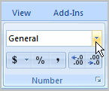

By default, the numbers appear in the General category, which means there is no special formatting.
In the Number group, you have some other options. For example, you can change the U.S. dollar sign to another currency format, numbers to percents, add commas, and change the decimal location.

Formatting Tables
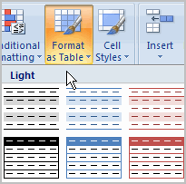
Once you have entered information into a spreadsheet, you may want to format it. Formatting your spreadsheet can not only make it look nicer, but make it easier to use. In a previous session we discussed many manual formatting options such as bold and italics. In this session, you will learn how to use the predefined tables styles in Excel 2007 and some of the Table Tools on the Design tab.

To Format Information as a Table:
- Select any cell that contains information.
- Click the Format as Table command in the Styles group on the Home tab. A list of predefined tables will appear.
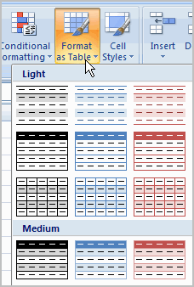

- Click a table style to select it.
- A dialog box will appear. Excel has automatically selected the cells for your table. The cells will appear selected in the spreadsheet and the range will appear in the dialog box.
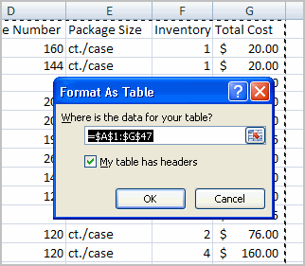

- Change the range listed in the field, if necessary.
- Verify the box is selected to indicate your table has headings, if it does. Deselect this box if your table does not have column headings.
- Click OK. The table will appear formatted in the style you chose.
By default, the table will be set up with the drop-down arrows in the header so that you can filter the table, if you wish.
In addition to using the Format as Table command, you can also select the Insert tab, and click the Table command to insert a table.

To Modify a Table:
- Select any cell in the table. The Table Tools Design tab will become active. From here you can modify the table in many ways.
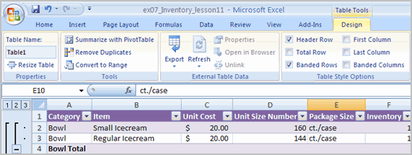
You can:
- Select a different table in the Table Styles Options group. Click the More drop-down arrow to see more table styles.
- Delete or add a Header Row in the Table Styles Options group.
- Insert a Total Row in the Table Styles Options group.
- Remove or add banded rows or columns.
- Make the first and last columns bold.
- Name your table in the Properties group.
- Change the cells that make up the table by clicking Resize Table.
When you apply a table style, filtering arrows automatically appear. To turn off filtering, select the Home tab, click the Sort & Filter command, and select Filter from the list.

Aligning Text
Worksheets that have not been formatted are often very difficult to read. Fortunately, Excel gives you many tools that allow you to format text and tables in various ways. One of the ways you can format your worksheet so that it is easier to work with is to apply different types of alignment to text.
In this lesson, you will learn how to left, center, and right align text, merge and center cells, vertically align text, and apply different types of text control.
Excel 2007 left-aligns text (labels) and right-aligns numbers (values). This makes data easier to read, but you do not have to use these defaults. Text and numbers can be defined as left-aligned, right-aligned or centered in Excel.

To Align Text or Numbers in a Cell:
- Select a cell or range of cells
- Click on either the Align Left, Center or Align Right commands on the Home tab.
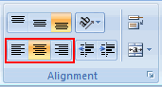

- The text or numbers in the cell(s) take on the selected alignment treatment.
Click a column label to select the entire column, or a row label to select an entire row.

Changing Vertical Cell Alignment
You can also define vertical alignment in a cell. In Vertical alignment, information in a cell can be located at the top of the cell, middle of the cell or bottom of the cell. The default is bottom.
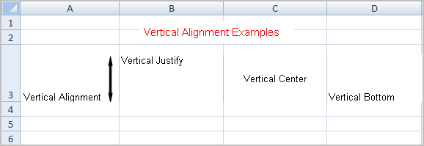

To Change Vertical Alignment from the Alignment Group:
- Select a cell or range of cells.
- Click the Top Align, Center, or Bottom Align command.
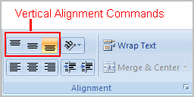

Changing Text Control
Text Control allows you to control the way Excel 2007 presents information in a cell. There are two common types of Text control: Wrapped Text and Merge Cells.
The Wrapped Text wraps the contents of a cell across several lines if it's too large than the column width. It increases the height of the cell as well.
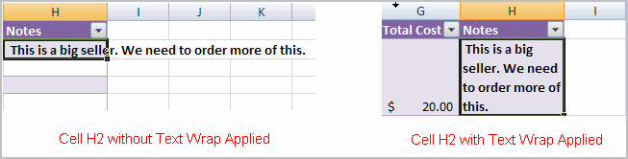

Merge Cells can also be applied by using the Merge and Center button on the Home tab.
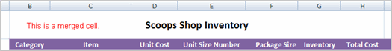

To Change Text Control:
- Select a cell or range of cells.
- Select the Home tab.
- Click the Wrap Text command or the Merge and Center command.
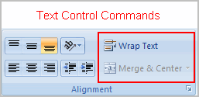
If you change your mind, click the drop-down arrow next to the command, and choose Unmerge cells.

Chapter 4

Formulas and Functions
Excel can be used to calculate and analyze numerical information; however, you will need to know how to write formulas to take maximize Excel's capabilities. A formula is an equation that performs a calculation using values in the worksheet. You will learn how to formulas using mathematical operators such as the addition, subtraction, multiplication, and division signs.

To Create a Formula that Adds Two Numbers:
- Click the cell where the formula will be defined (C5, for example).
- Type the equal sign (=) to let Excel know a formula is being defined.
- Type the first number to be added (e.g., 1500)
- Type the addition sign (+) to let Excel know that an add operation is to be performed.
- Type the second number to be added (e.g., 200)
- Press Enter or click the Enter button on the Formula bar to complete the formula.
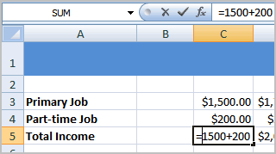

To Create a Simple Formula that Adds the Contents of Two Cells:
- Click the cell where the answer will appear (C5, for example).
- Type the equal sign (=) to let Excel know a formula is being defined.
- Type the cell number that contains the first number to be added (C3, for example).
- Type the addition sign (+) to let Excel know that an add operation is to be performed.
- Type the cell address that contains the second number to be added (C4, for example).
- Press Enter or click the Enter button on the Formula bar to complete the formula.
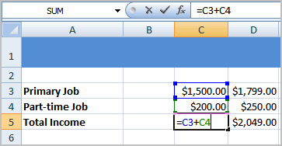

To Create a Simple Formula using the Point and Click Method:
- Click the cell where the answer will appear (C30, for example).
- Type the equal sign (=) to let Excel know a formula is being defined.
- Click on the first cell to be included in the formula (C5, for example).
- Type the subtraction sign (-) to let Excel know that a subtraction operation is to be performed.
- Click on the next cell in the formula (C29, for example).
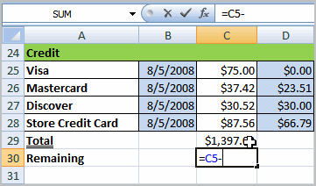
- Press Enter or click the Enter button on the Formula bar to complete the formula.
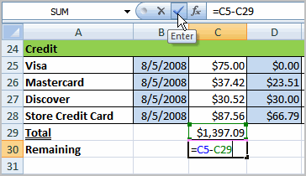

To Create a Simple Formula that Multiplies the Contents of Two Cells:
- Select the cell where the answer will appear (E32, for example).
- Type the equal sign (=) to let Excel know a formula is being defined.
- Click on the first cell to be included in the formula (C9, for example) or type a number.
- Type the multiplication symbol (*) by pressing the Shift key and then the number 8 key. The operator displays in the cell and Formula bar.
- Click on the next cell in the formula or type a number (12, for example).
- Press Enter or click the Enter button on the Formula bar to complete the formula.
.
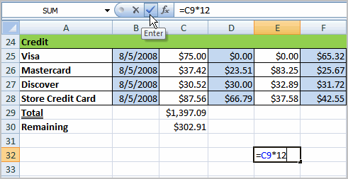

To Create a Simple Formula that Divides One Cell by Another:
- Click the cell where the answer will appear.
- Type the equal sign (=) to let Excel know a formula is being defined.
- Click on the first cell to be included in the formula.
- Type a division symbol. The operator displays in the cell and Formula bar.
- Click on the next cell in the formula.
- Enter or click the Enter button on the Formula bar to complete the formula.

Creating More Formulas
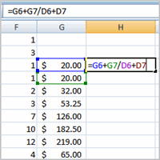
Excel is a spreadsheet application and is intended to be used to calculate and analyze numerical information such as household budgets, company finances, inventory, and more. To do this, you need to understand formulas.
We’ll now discuss formulas that use multiple mathematical operators, and that use absolute and relative references.
.
To calculate formulas that use multiple mathematical operators correctly, you must perform certain operations before others. This is defined in the order of operations.

The Order of Operations
The order of mathematical operations is very important. If you enter a formula that contains several operations, Excel knows to work those operations in a specific order. The order of operations is:
- Operations enclosed in parenthesis
- Exponential calculations (to the power of)
- Multiplication and division, whichever comes first
- Addition and subtraction, whichever comes first

Example 1
Using this order, let us see how the formula 20/(8-4)*8-2 is calculated in the following breakdown:
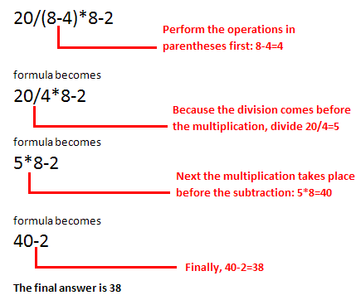

Example 2
3+3*2=?
Is the answer 12 or 9? Well, if you calculated in the order in which the numbers appear, 3+3*2, you'd get the wrong answer, 12. You must follow the order of operations to get the correct answer 9
Excel automatically follows a standard order of operations in a formula. If you want a certain portion of the formula to be calculated first, put it in parentheses.

Example of How to Write a Complex Formula:
- Click the cell where you want the formula result to appear. In this example, H6.
- Type the equal sign (=) to let Excel know a formula is being defined.
- Type an open parenthesis, or (
- Click on the first cell to be included in the formula (G6, for example).
- Type the addition sign (+) to let Excel know that an add operation is to be performed.
- Click on the second cell in the formula (G7, for example)
- Type a close parentheses ).
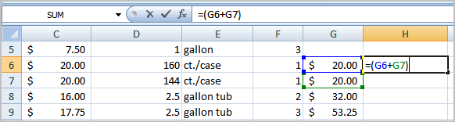

- Type the next mathematical operator, or the division symbol (/) to let Excel know that a division operation is to be performed.
- Type an open parenthesis, or (
- Click on the third cell to be included in the formula (D6, for example).
- Type the addition sign (+) to let Excel know that an add operation is to be performed.
- Click on the fourth cell to be included in formula. (D7, for example).
- Type a close parentheses ).
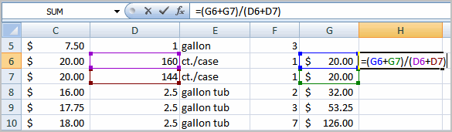

- Very Important: Press Enter or click the Enter button on the Formula bar. This step ends the formula.
To show fewer decimal places, you can just click the Decrease Decimal place command on the Home tab.

Working with Cells
It is important to know how to move information from one cell to another in Excel. Learning the various ways will save you time and make working with Excel easier. Certain methods are more appropriate depending on how much information you need to move and where it will reside on the spreadsheet. In this lesson you will learn how to cut, copy, and paste, as well as drag and drop information.

To Copy and Paste Cell Contents:
- Select the cell or cells you wish to copy.
- Click the Copy command in the Clipboard group on the Home tab. The border of the selected cells will change appearance.
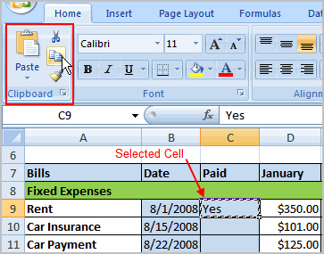

- Select the cell or cells where you want to paste the information.
- Click the Paste command. The copied information will now appear in the new cells.
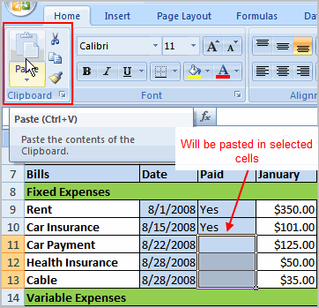

To select more than one adjoining cell, Click one of the cells, drag the cursor until all the cells are selected, and release the mouse button.
The copied cell will stay selected until you perform your next task, or you can double-click the cell to deselect it.

To Cut and Paste Cell Contents:
- Select the cell or cells you wish to copy.
- Click the Cut command in the Clipboard group on the Home tab. The border of the selected cells will change appearance.
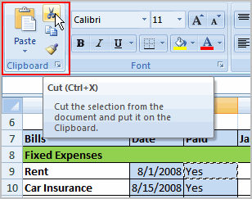

- Select the cell or cells where you want to paste the information.
- Click the Paste command. The cut information will be removed from the original cells and now appear in the new cells.
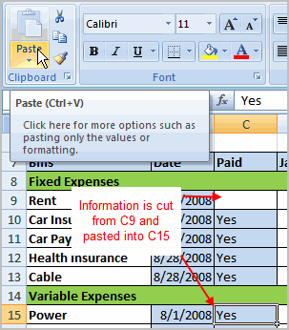

The keyboard shortcut for Paste is the Control Key and the V key.

To Drag and Drop Information:
- Select the cell or cells you wish to move.
- Position your mouse pointer near one of the outside edges of the selected cells. The mouse pointer changes from a large, white cross to a black cross with 4 arrows.
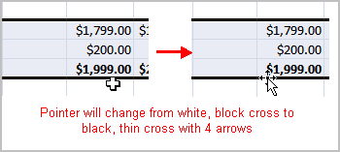

- Click and hold the mouse button and drag the cells to the new location.
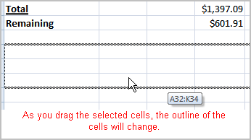

- Release the mouse button and the information appears in the new location.

To Use the Fill Handle to Fill Cells:
- Position your cursor over the fill handle until the large white cross becomes a thin, black cross.
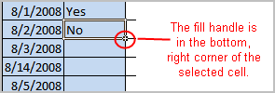

- Click your mouse and drag it until all the cells you want to fill are highlighted.
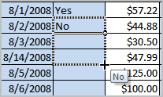

- Release the mouse button and all the selected cells are filled with the information from the original cell.
The fill handle doesn't always copy information from one cell directly into another cell. Depending on the data entered in the cell, it may fill the data in other ways. For example, if I have the formula =A1+B1 in cell C1, and I use the fill handle to fill the formula into cell C2, the formula doesn't appear the same in C2 as it does in C1. Instead of =A1+B1, you will see =A2+B2.
You can use the fill handle to fill cells horizontally or vertically.

Using Cell References
As you can see, there are many ways to create a formula in Excel. Most likely you will choose one of the methods that enters the cell address into the formula, rather than an actual number. The cell address is basically the name of the cell and can be found in the Name Box.

The following example uses actual numbers in the formula in C5.

When a cell address is used as part of a formula, this is called a cell reference. It is called a cell reference because instead of entering specific numbers into a formula, the cell address refers to a specific cell. The following example uses cell references in the formula in C30.

What is an Absolute Reference?
We saw how cell references in formulas automatically adjust to new locations when the formula is pasted into different cells. This is called a relative reference.

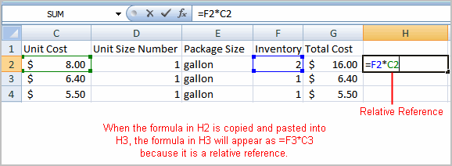

Sometimes, when you copy and paste a formula, you don't want one or more cell references to change. Absolute reference solves this problem. Absolute cell references in a formula always refer to the same cell or cell range in a formula. If a formula is copied to a different location, the absolute reference remains the same.
An absolute reference is designated in the formula by the addition of a dollar sign ($). It can precede the column reference or the row reference, or both. Examples of absolute referencing include:

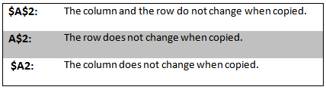

To Create an Absolute Reference:
- Select the cell where you wish to write the formula (in this example, H2)
- Type the equal sign (=) to let Excel know a formula is being defined.
- Click on the first cell to be included in the formula (F2, for example).
- Enter a mathematical operator (use the multiplication symbol for this example).
- Click on the second cell in the formula (C2, for example).
- Add a $ sign before the C and a $ sign before the 2 to create an absolute reference.
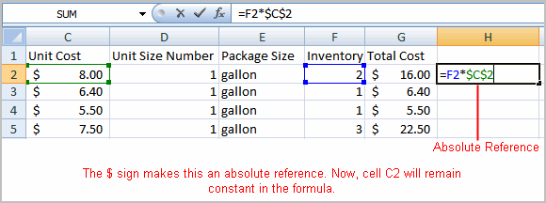

- Copy the formula into H3. The new formula should read =F3*$C$2. The F2 reference changed to F3 since it is a relative reference, but C2 remained constant since you created an absolute reference by inserting the dollar signs.
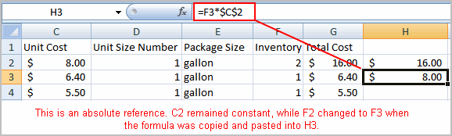

Functions
A function is a predefined formula that performs calculations using specific values in a particular order. While you may think of formulas as being short mathematical equations, like 2 + 2 or F2 * C2, they can actually be very lengthy and involve complex mathematical calculations.
One of the key benefits of functions is that they can save you time since you do not have to write the formula yourself. For example, you could use an Excel function called Average to quickly find the average of a range of numbers or the Sum function to find the sum of a cell range.
In this lesson, you will learn how to use basic functions such as SUM and AVG, use functions with more than one argument, and how to access the other Excel 2007 functions.

The Parts of a Function:
Each function has a specific order, called syntax, which must be strictly followed for the function to work correctly.
Syntax Order:
- All functions begin with the = sign.
- After the = sign define the function name (e.g., Sum).
- Then there will be an argument. An argument is the cell range or cell references that are enclosed by parentheses. If there is more than one argument, separate each by a comma.
An example of a function with one argument that adds a range of cells, A3 through A9:
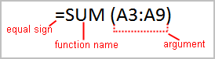

An example of a function with more than one argument that calculates the sum of two cell ranges:
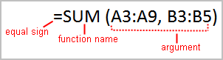

Excel literally has hundreds of different functions to assist with your calculations. Building formulas can be difficult and time-consuming. Excel's functions can save you a lot of time and headaches.

Excel's Different Functions
There are many different functions in Excel 2007. Some of the more common functions include:

Statistical Functions:
- SUM - summation adds a range of cells together.
- AVERAGE - average calculates the average of a range of cells.
- COUNT - counts the number of chosen data in a range of cells.
- MAX - identifies the largest number in a range of cells.
- MIN - identifies the smallest number in a range of cells.

Financial Functions:
- Interest Rates
- Loan Payments
- Depreciation Amounts

Date and Time functions:
- DATE - Converts a serial number to a day of the month
- Day of Week
- DAYS360 - Calculates the number of days between two dates based on a 360-day year
- TIME - Returns the serial number of a particular time
- HOUR - Converts a serial number to an hour
- MINUTE - Converts a serial number to a minute
- TODAY - Returns the serial number of today's date
- MONTH - Converts a serial number to a month
- YEAR - Converts a serial number to a year
You don't have to memorize the functions but should have an idea of what each can do for you.

To Calculate the Sum of a Range of Data Using AutoSum:
- Select the Formulas tab.
- Locate the Function Library group. From here, you can access all the available functions.
- Select the cell where you want the function to appear. In this example, select G42.
- Select the drop-down arrow next to the AutoSum command.
- Select Sum. A formula will appear in the selected cell, G42.
  - This formula, =SUM(G2:G41), is called a function. AutoSum command automatically selects the range of cells from G2 to G41, based on where you inserted the function. You can alter the cell range, if necessary.
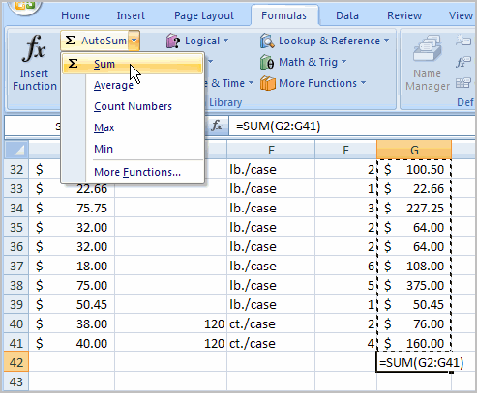
- Press the Enter key or Enter button on the formula bar. The total will appear.

To Edit a Function:
- Select the cell where the function is defined.
- Insert the cursor in the formula bar.
- Edit the range by deleting and changing necessary cell numbers.
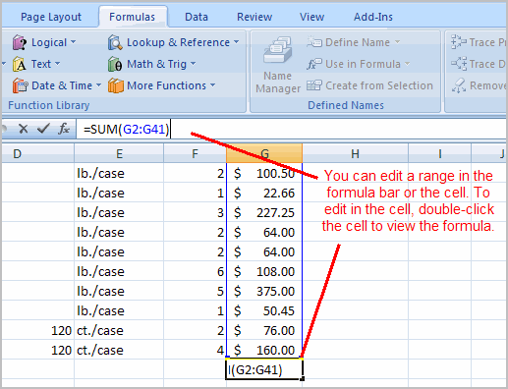
- Click the Enter icon.

To Calculate the Sum of Two Arguments:
- Select the cell where you want the function to appear. In this example, G44.
- Click the Insert Function command on the Formulas tab. A dialog box appears.
- SUM is selected by default.
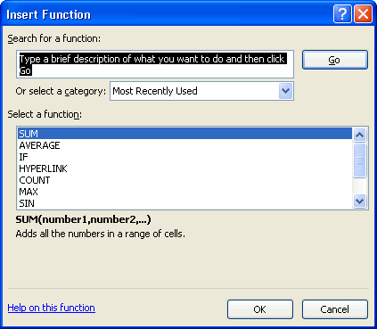

- Click OK and the Function Arguments dialog box appears so that you can enter the range of cells for the function.
- Insert the cursor in the Number 1 field.
- In the spreadsheet, select the first range of cells. In this example, G21 through G26. The argument appears in the Number 1 field.
  - To select the cells, Click cell G21 and drag the cursor to G26, and then release the mouse button.
- Insert the cursor in the Number 2 field.
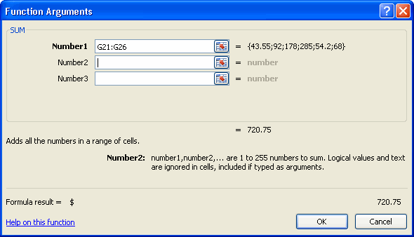

- In the spreadsheet, select the second range of cells. In this example, G40 through G41. The argument appears in the Number 2 field.
- Notice that both arguments appear in the function in cell G44 and the formula bar when G44 is selected.
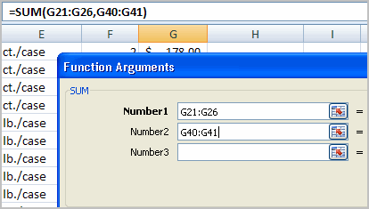

- Click OK in the dialog box and the sum of the two ranges is calculated.

To Calculate the Average of a Range of Data:
- Select the cell where you want the function to appear.
- Click the drop-down arrow next to the AutoSum command.
- Select Average.
- Click on the first cell (in this example, C8) to be included in the formula.
- Click and drag the mouse to define a cell range (C8 through cell C20, in this example).
- Click the Enter icon to calculate the average.

Accessing Excel 2007 Functions

To Access Other Functions in Excel:
- Using the point-click-drag method, select a cell range to be included in the formula.
- On the Formulas tab, click on the drop-down part of the AutoSum button.
- If you don't see the function you want to use (Sum, Average, Count, Max, Min), display additional functions by selecting More Functions.
- The Insert Function dialog box opens.
- There are three ways to locate a function in the Insert Function dialog box:
You can type a question in the Search for a function box and click GO, or
You can scroll through the alphabetical list of functions in the Select a function field, or
You can select a function category in the Select a category drop-down list and review the corresponding function names in the Select a function field.
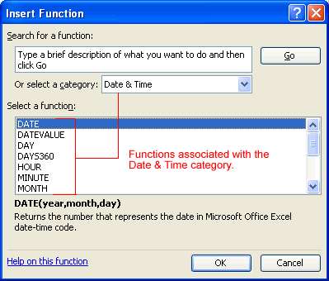
- Select the function you want to use and then click the OK button.

Chapter 5

Sorting, Grouping, and Filtering Cells
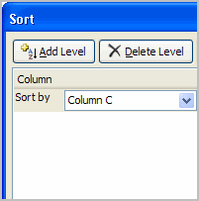
A Microsoft Excel spreadsheet can contain a great deal of information. With more rows and columns than previous versions, Excel 2007 gives you the ability to analyze and work with an enormous amount of data. To most effectively use this data, you may need to manipulate this data in different ways.
In this lesson, you will learn how to sort, group, and filter data in various ways that will enable you to most effectively and efficiently use spreadsheets to locate and analyze information.

Sorting, Grouping, and Filtering
A Microsoft Excel spreadsheet can contain a great deal of information. Sometimes you may find that you need to reorder or sort that information, create groups, or filter information to be able to use it most effectively.

Sorting
Sorting lists is a common spreadsheet task that allows you to easily reorder your data. The most common type of sorting is alphabetical ordering, which you can do in ascending or descending order.

To Sort in Alphabetical Order:
- Select a cell in the column you want to sort (In this example, we choose a cell in column A).
- Click the Sort & Filter command in the Editing group on the Home tab.
- Select Sort A to Z. Now the information in the Category column is organized in alphabetical order.
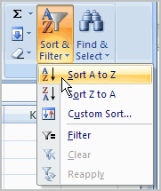

You can search in reverse alphabetical order by choosing Sort Z to A in the list.

To Sort from Smallest to Largest:
- Select a cell in the column you want to sort (a column with numbers).
- Click the Sort & Filter command in the Editing group on the Home tab.
- Select From Smallest to Largest. Now the information is organized from the smallest to largest amount.
You can sort in reverse numerical order by choosing From Largest to Smallest in the list.

To Sort Multiple Levels:
- Click the Sort & Filter command in the Editing group on the Home tab.
- Select Custom Sort from the list to open the dialog box.
OR
- Select the Data tab.
- Locate the Sort and Filter group.
- Click the Sort command to open the Custom Sort dialog box. From here, you can sort by one item, or multiple items.
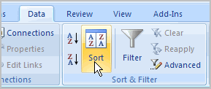

- Click the drop-down arrow in the Column Sort by field, and choose one of the options. In this example, Category.
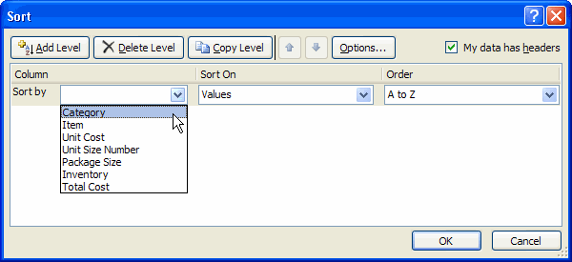

- Choose what to sort on. In this example, we'll leave the default as Value.
- Choose how to order the results. Leave it as A to Z so it is organized alphabetically.
- Click Add Level to add another item to sort by.
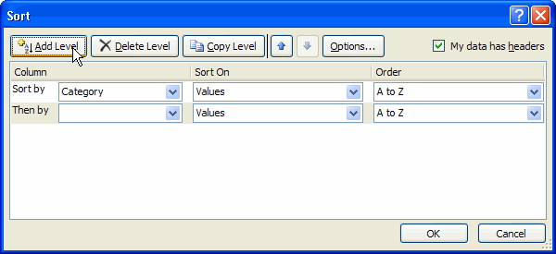

- Select an option in the Column Then by field. In this example, we chose Unit Cost.
- Choose what to sort on. In this example, we'll leave the default as Value.
- Choose how to order the results. Leave it as smallest to largest.
- Click OK.
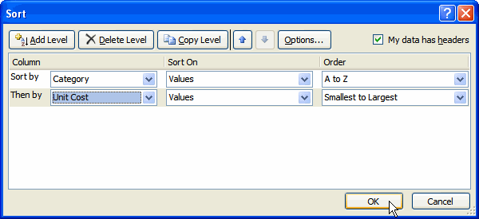

The spreadsheet has been sorted. All the categories are organized in alphabetical order, and within each category, the unit cost is arranged from smallest to largest.
Remember all of the information and data is still here. It's just in a different order.

Grouping Cells Using the Subtotal Command
Grouping is a really useful Excel feature that gives you control over how the information is displayed. You must sort before you can group. In this section we will learn how to create groups using the Subtotal command.

To Create Groups with Subtotals:
- Select any cell with information in it.
- Click the Subtotal command. The information in your spreadsheet is automatically selected and the Subtotal dialog box appears.
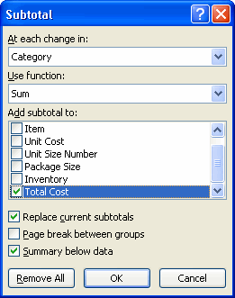

- Decide how you want things grouped. In this example, we will organize by Category.
- Select a function. In this example, we will leave the SUM function selected.
- Select the column you want the Subtotal to appear. In this example, Total Cost is selected by default.
- Click OK. The selected cells are organized into groups with subtotals.
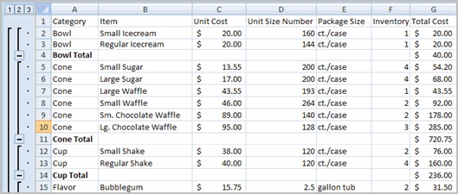

To Collapse or Display the Group:
- Click the black minus sign, which is the hide detail icon, to collapse the group.
- Click the black plus sign, which is the show detail icon, to expand the group.
- Use the Show Details and Hide Details commands in the Outline group to collapse and display the group, as well.
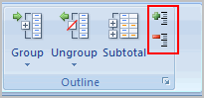

To Ungroup Select Cells:
- Select the cells you want to remove from the group.
- Click the Ungroup command.
- Select Ungroup from the list. A dialog box will appear.
- Click OK.

To Ungroup the Entire Worksheet:
- Select all the cells with grouping.
- Click Clear Outline from the menu.

Filtering Cells
Filtering, or temporarily hiding, data in a spreadsheet very easy. This allows you to focus on specific spreadsheet entries.

To Filter Data:
- Click the Filter command on the Data tab. Drop-down arrows will appear beside each column heading.
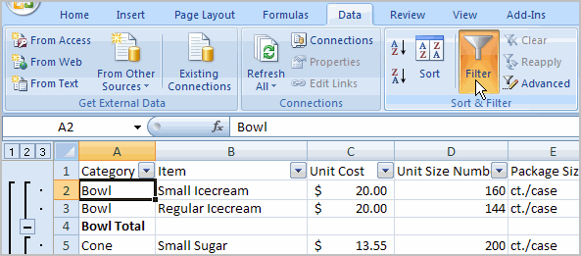

- Click the drop-down arrow next to the heading you would like to filter. For example, if you would like to only view data regarding Flavors, click the drop-down arrow next to Category.
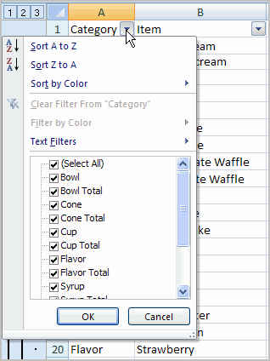
- Uncheck Select All.
- Choose Flavor.
- Click OK. All other data will be filtered, or hidden, and only the Flavor data is visible.

To Clear One Filter:
- Select one of the drop-down arrows next to a filtered column.
- Choose Clear Filter From....
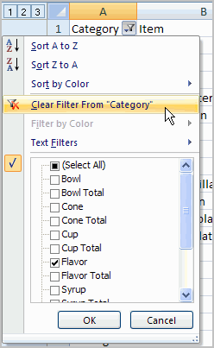

To remove all filters, click the Filter command.
Filtering may look a little like grouping, but the difference is that now I can filter on another field, if I want to. For example, let’s say I want to see only the Vanilla-related flavors. I can click the drop-down arrow next to Item, and select Text Filters. From the menu, I’ll choose Contains because I want to find any entry that has the word vanilla in it. A dialog box appears. We’ll type Vanilla, and then click OK. Now we can see that the data has been filtered again and that only the Vanilla-related flavors appear.

Chapter 6

Using What-if Analysis
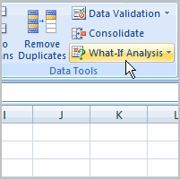
The real power in Excel comes in its ability to perform multiple mathematical calculations for you. One of the tools in Excel that you can use to perform these calculations is a Data tool called What-If Analysis. What-If analysis allows you to see the effect that different values have in formulas. Have you ever thought, "What interest rate do I need to qualify for to have a car payment of $400 on the car I want?" This question can be answered using What-If Analysis.
In this lesson, you will learn how to use a What-If Analysis tool called Goal Seek.

Example
You need a loan to buy a new car. You know how much money you want to borrow, how long of a period you want to take to pay off the loan (the term), and what payment you can afford to make each month. But, what you need to know is what interest rate you to qualify for to make the payment $400 a month. In the image below, you can see that if you didn’t have interest and just divided this $20,000 into 60 monthly payments, you would pay $333.33 a month. The What-If Analysis tool will allow you to easily calculate the interest rate.
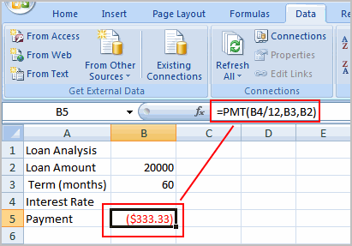

Where Did the Formula Come From?
The formula that appears in cell B5 in the example image is a function. It isn't part of the What-if Analysis tool, so you will need to understand functions thoroughly before you use What-if Analysis. For the example scenario described above, you need a formula that will calculate the monthly payment. Instead of writing the formula yourself, you can insert a function to do the calculation for you.

To Insert a Payment Function:
- Select the Formula tab.
- Click the Insert Function command. A dialog box appears.
- Select PMT.
- Click OK. A dialog box appears.
- Insert your cursor in the first field. A description about the needed information appears at the bottom of the dialog box.
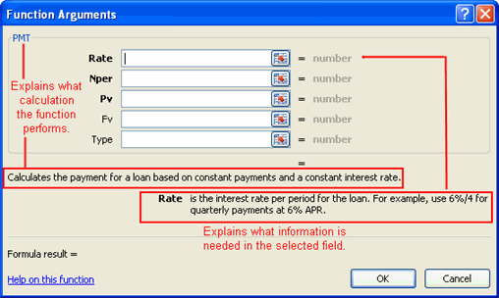

- Select the cell in the spreadsheet with the needed information.
- Insert your cursor in the next field. A description about the needed information appears at the bottom of the dialog box.
- Select the cell in the spreadsheet with the needed information.
- Repeat the last two steps until all the necessary information is entered in the dialog box.
- Click OK.

What-If Analysis Tools
There are three What-If analysis tools that you can use. To access these, select the Data tab, and locate the What-If Analysis command. If you click this command, a menu with three options appears.
Goal seek is useful if you know the needed result, but need to find the input value that will give you the desired result. In this example, we know the desired result (a $400 monthly payment), and are seeking the input value (the interest rate).

Goal Seek

To Use Goal Seek to Determine an Interest Rate:
- Select the Data tab.
- Locate the Data Tools group.
- Click the What-If Analysis command. A list of three options appears.
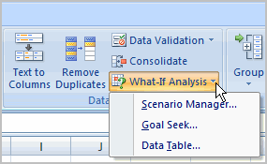

- Select Goal Seek. A small dialog box appears.
- Select the cell that you what to set to a specific value. In this example, we want to set B5, the Payment cell.
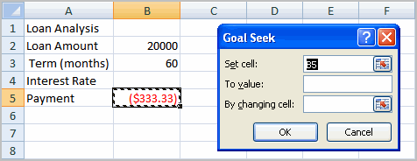

- Insert the cursor in the next field.
- Enter a value in the value field. In this example, type -$400. Since we’re making a payment that will be subtracted from our loan amount, we have to enter the payment as a negative number.
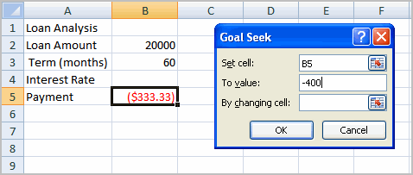

- Insert the cursor in the next field.
- Select the cell that you want to change. This will be the cell that tries various input values. In this example, select cell B4, which is the interest rate.
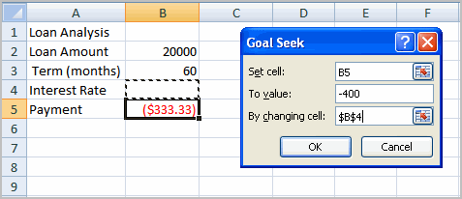

- Click OK.
- Then, click OK again. The interest rate appears in the cell. This indicates that a 7% interest rate will give us a $400 a month payment on a $20,000 loan that is paid off over 5 years, or 60 months.
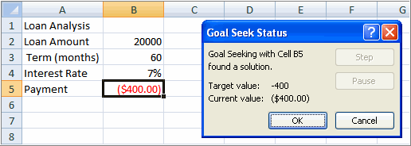

Chapter 7

Working with Charts
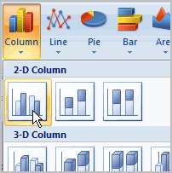
A chart is a tool you can use in Excel to communicate your data graphically. Charts allow your audience to more easily see the meaning behind the numbers in the spreadsheet, and make showing comparisons and trends a lot easier. In this lesson, you will learn how to insert and modify Excel charts and see how they can be an effective tool for communicating information.

Creating a Chart
Charts can be a useful way to communicate data. When you insert a chart in Excel, it appears in the selected worksheet with the source data, by default.

To Create a Chart:
- Select the worksheet you want to work with. In this example, we use the Summary worksheet.
- Select the cells that you want to chart, including the column titles and the row labels.
- Click the Insert tab.
- Hover over each Chart option in the Charts group to learn more about it.
- Select one of the Chart options. In this example, we use the Columns command.
- Select a type of chart from the list that appears. For this example, we use a 2-D Clustered Column. The chart appears in the worksheet.
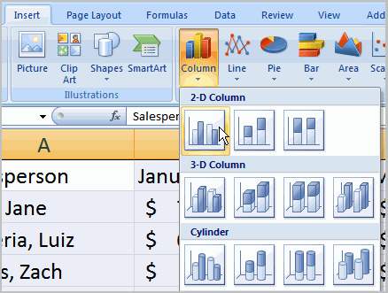

Identifying the Parts of a Chart
Have you ever read something you didn't fully understand but when you saw a chart or graph, the concept became clear and understandable? Charts are a visual representation of data in a worksheet. Charts make it easy to see comparisons, patterns, and trends in the data.
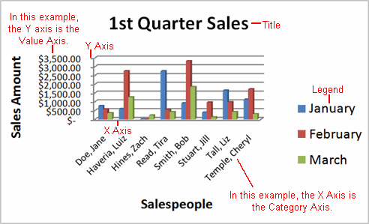

Source Data - The range of cells that make up a chart. The chart is updated automatically whenever the information in these cells change.

Title- The title of the chart.

Legend - The chart key, which identifies each color on the chart represents.

Axis - The vertical and horizontal parts of a chart. The vertical axis is often referred to as the Y axis, and the horizontal axis is referred to as the X axis.

Data Series - The actual charted values, usually rows or columns of the source data.

Value Axis - The axis that represents the values or units of the source data.

Category Axis - The axis identifying each data series.

Chart Tools
Once you insert a chart, a new set of Chart Tools, arranged into 3 tabs, will appear above the Ribbon. These are only visible when the chart is selected.
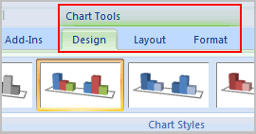

To Change the Chart Type:
- Select the Design tab.
- Click the Change Chart Type command. A dialog box appears.
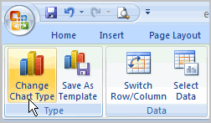

- Select another chart type.
- Click OK.
The chart in the example compares each salesperson's monthly sales to his/her other month's sales; however you can change what is being compared. Just click the Switch Row/Column Data command, which will rotate the data displayed on the x and y axes. To return to the original view, click the Switch Row/Column command again.

To Change Chart Layout:
- Select the Design tab.
- Locate the Chart Layouts group.
- Click the More arrow to view all your layout options.
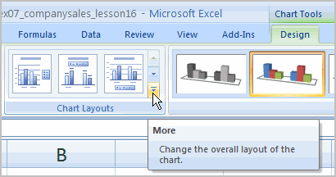

- Click a layout to select it.
If your new layout includes chart titles, axes, or legend labels, just insert your cursor into the text and begin typing to add your own text.

To Change Chart Style:
- Select the Design tab.
- Locate the Chart Style group.
- Click the More arrow to view all your style options.
- Click a style to select it.
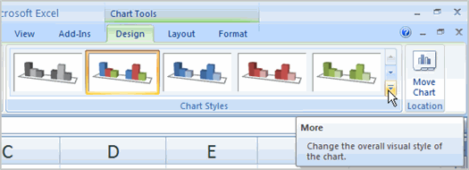

To Move the Chart to a Different Worksheet:
- Select the Design tab.
- Click the Move Chart command. A dialog box appears. The current location of the chart is selected.
- Select the desired location for the chart (i.e., choose an existing worksheet, or select New Sheet and name it).
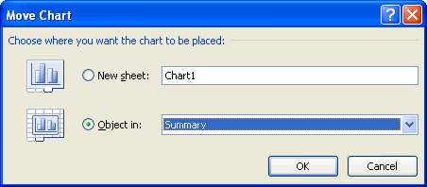

Chapter 8

Printing Workbooks
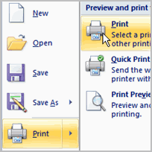In Excel, there are many things you can do to prepare your workbook for printing. Many of these tasks make it easier to format the spreadsheet for the printed page.
In this lesson you will learn how to view the spreadsheet in print preview, modify margins, change the page orientation, use the scale to fit feature, use the Print Tiles command, insert breaks, and more.

Preparing to Print and Printing

To View the Spreadsheet in Print Preview:
- Click the Microsoft Office Button.
- Select Print.
- Select Print Preview. The spreadsheet will appear in Print Preview view.
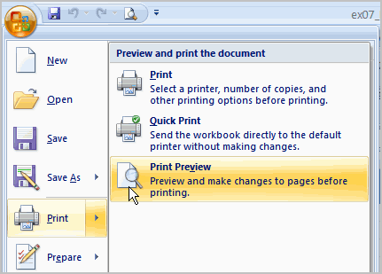

Click the Close Print Preview button to return to the Normal View.
To make previewing your spreadsheet easier, add the Print Preview command to the Quick Access toolbar.

Exploring Print Preview:
Once you are in Print Preview, you can access many of the same features that you can from the Ribbon; however, in Print Preview you can see how the spreadsheet will appear in printed format.

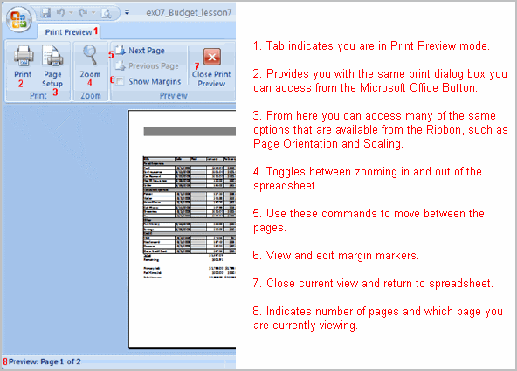

To Modify Margins, Column Width, or Row Height While in Print Preview:
- Click the Print Preview command on the Quick Access toolbar, or select Print Preview from the Microsoft Office Button menu. The spreadsheet opens in print preview mode.
- Hover your cursor over one of the black margin markers until a double arrow appears.
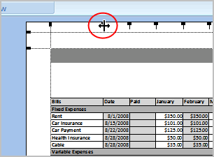
- Click and drag the marker to the desired location. The change will be reflected in the spreadsheet.

To Modify Margins:
- Select the Page Layout tab.
- Click the Margins command.
- Choose one of the predefined settings or enter custom margins.
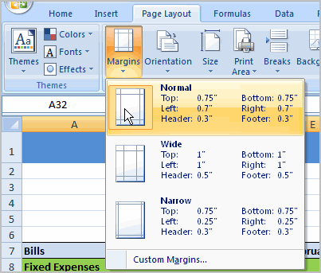

To Change Page Orientation:
- Select the Page Layout tab.
- Click the Orientation command.
- Select either Portrait or Landscape.
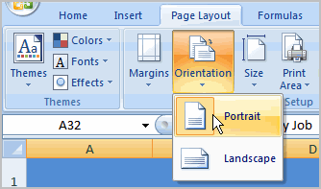
Portrait orients the page vertically, while Landscape orients the page horizontally.

To Use Scale to Fit:
- Select the Page Layout tab.
- Locate the Scale to Fit group.
- Enter a specific height and width, or use the percentage field to decrease the spreadsheet by a specific percent.
Scale to Fit is a useful feature that can help you format spreadsheets to fit on a page. Be careful with how small you scale the information -- it can become difficult to read!

To Change the Paper Size:
- Select the Page Layout tab.
- Click the Size command.
- Select a size option from the list.

To Define a Print Area:
- Click and drag your mouse to select the cells you wish to print.
- Click the Print Area command.
- Choose Set Print Area.
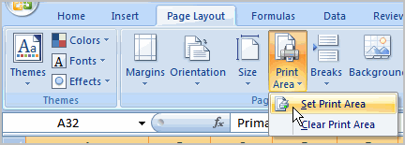
Now, only the selected cells will print. You can confirm this by viewing the spreadsheet in Print Preview.
To return to the default setting, which is the entire worksheet, click the Print Area command and select Clear Print Area.

To Insert a Break:
- Select a cell below where you want the break to appear.
- Select the Breaks command.
- Select Insert Break.
Click Print Preview to confirm the break appears in the correct place in your spreadsheet.

To Use the Print Titles command:
This is an important command to be familiar with if you intend to print your worksheets. It allows you to select specific rows and/or columns to appear on each printed sheet. Imagine how difficult it would be to read page 48 of a printed spreadsheet if the column and row headings only appeared on the first page.
- Select the Page Layout tab.
- Click the Print Titles command. The Page Setup dialog box appears.
- Click the icon at the end of the field.
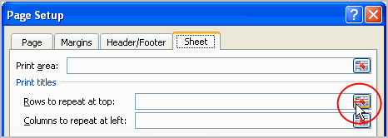

- Select the first row in the spreadsheet that you want to appear on each printed page.
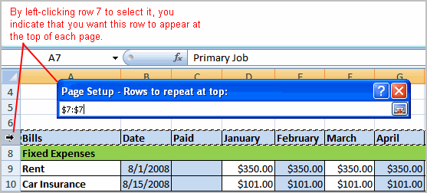
- Repeat for the column, if necessary.
- Click OK.

To Print from the Microsoft Office Button:
- Click the Microsoft Office Button.
- Select Print Print. The Print dialog box appears.
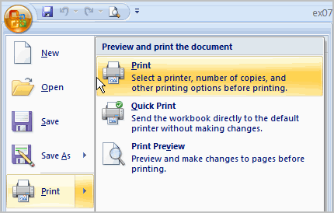
- Select a printer if you wish to use a printer other than the default setting.
- Click Properties to change any necessary settings.
- Choose whether you want to print specific pages, all of the worksheet, a selected area, the active sheet, or the entire workbook.
- Select the number of copies you'd like to print.
- Click OK.
You can select Quick Print to bypass the Print dialog box.

